
Experiment 3
Hybrid Cloud Connectivity Using Cisco Packet Tracer

AIM:
To create a hybrid cloud network in Cisco Packet Tracer by connecting an on-premises network with a cloud network. This experiment helps in understanding how routers, switches, IP addressing, and static routing are used to establish communication between two different networks.

WhatisHybrid Cloud?
A hybrid cloud is a combination of a private network and a public cloud. The private network belongs to an organization, while the public cloud is provided by cloud service providers such as AWS or Azure. Both networks are securely connected so that they can exchange data and resources.

PROCEDURE:

Step1
Create a Cisco Networking Academy (NetAcad) account or sign in using your existing Google account.

Step 2
Enroll in the free course "Getting Started with Cisco Packet Tracer."
Step 3
Download the Packet Tracer software suitable for your operating system and complete the installation.
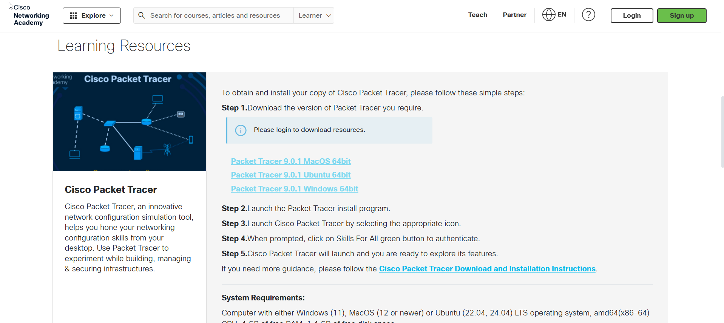

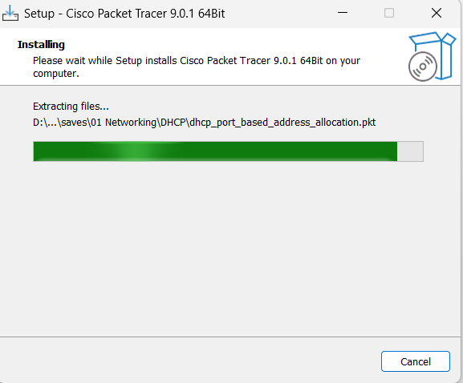

Step 4
Launch Cisco Packet Tracer and log in using your NetAcad account. A blank workspace will appear
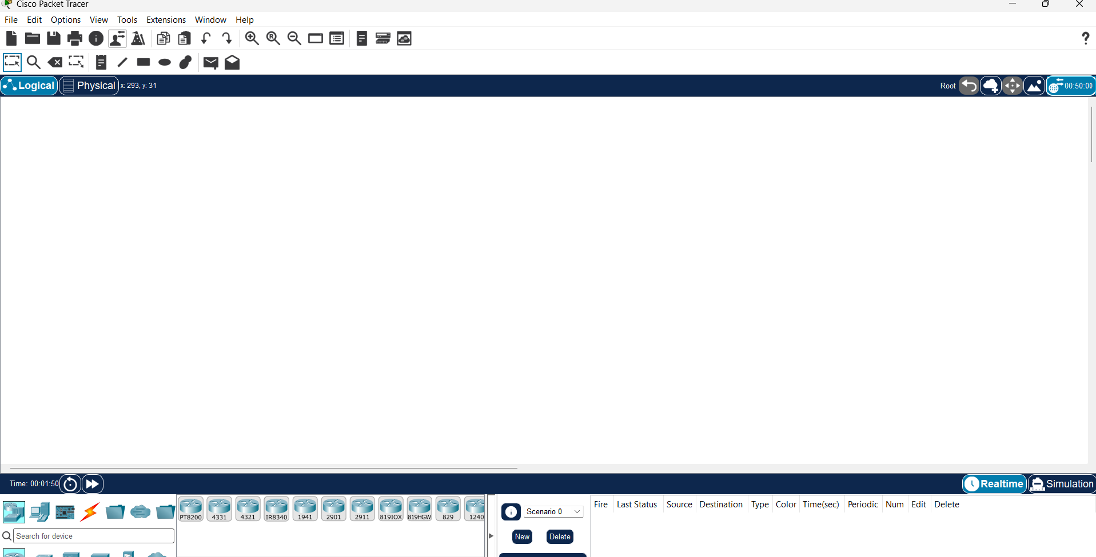

Step 5
Add the required network devices to the workspace:
- Two Routers
- Two Switches
- One PC
- One Server
Arrange the devices so that one router and switch represent the on-premises network, while the other router and switch represent the cloud network.
Step 6
Connect the devices using the appropriate cables:
- Connect the PC to Switch0.
- Connect Switch0 to Router0.
- Connect the Server to Switch1.
- Connect Switch1 to Router1.
- Finally, connect Router0 and Router1 using a crossover cable.

Step 7
Open the CLI of Router0 and configure the interfaces by assigning IP addresses to the LAN network and the router-to-router connection. Enable the interfaces using the no shutdown command.
Step 8
Repeat the same process for Router1 by assigning the required IP addresses and enabling both interfaces.
Step 9
Verify that all router interfaces are active using the show ip interface brief command. The interface status should display up/up.
Step 10
Configure the PC with the following details:
- IP Address: 192.168.1.10
- Subnet Mask: 255.255.255.0
- Default Gateway: 192.168.1.1
Configure the Server with:
- IP Address: 10.0.0.10
- Subnet Mask: 255.255.255.0
- Default Gateway: 10.0.0.1
Step 11
Configure static routes on both routers so that each router knows how to reach the other network. Save the configuration and verify that the routes are added successfully using the show ip route command.
Step 12
Open the Command Prompt on the PC and use the ping command to check communication with the server. If the ping is successful, it confirms that the hybrid cloud network is working correctly.

RESULT
The hybrid cloud network was created successfully in Cisco Packet Tracer. Communication between the on-premises PC and the cloud server was verified using the ping command, confirming successful network connectivity.

CONCLUSION
This experiment helped me understand how a hybrid cloud network can be simulated using Cisco Packet Tracer. I learned how to connect network devices, configure router interfaces, assign IP addresses, add static routes, and test communication between two different networks. The successful ping test confirmed that the hybrid cloud connection was established correctly.

